

FYN Enhancement

|  |
| --- |
| Requirement No.: FYN_Phase2_BRD_1  Module: Account Service |

|  |  |  |  |
| --- | --- | --- | --- |
| Version | Author | Date | Changes |
| 1.0 | Neema Thaikkattil | 21/Feb/2023 | Base Version |
| 1.1 | Tushar Thakur | 21/Feb/2023 | Review and updated |

# Business Requirement /Problem Statement

Now Account Module on FYN in Phase II is live, and business team has come up with new requirement/changes in existing feature, basis the feedback received during CUG Lunch.

Business and BSG team has short listed those Feedback/changes. This Document Contained changes which has to be taken on priority.

# Change:

Below is the list of changes that has to be incorporated in FYN:

**Req_1 :**

**Screen: Recent Transaction Widget**

Current Scenario: Transaction displayed in bank base currency.

Expected Change: This is a functional change. Transaction to be displayed in account base currency. Depending on the currency of the account, the abbreviation (INR, USD, etc. should reflecting against the transaction amount displayed). Data coming from Finacle API. According changes should reflect in the pop-up displayed after clicking on the transaction.

Screenshot:

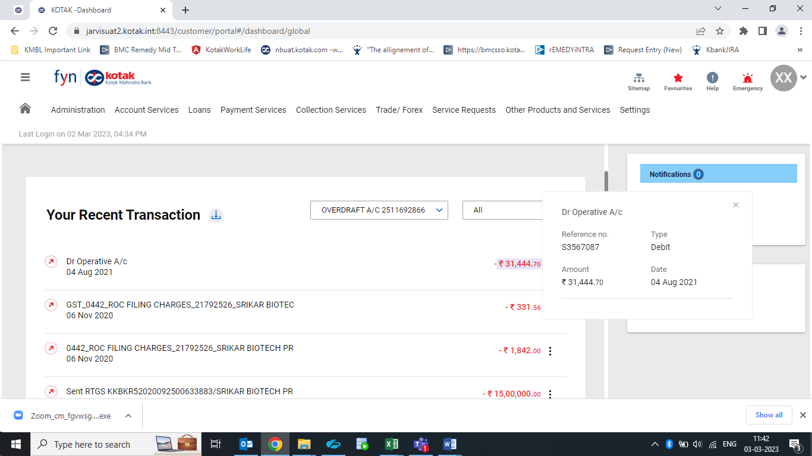

**Req_2 :**

**Screen: Your Summary widget**

Current Scenario: The logic is supported for OD scheme code but not for CA and SA. Logic : if an account has positive balance, it needs to be covered under assets & if it has negative balance, it needs to be covered under liabilities. Negative balances are primarily on account of utilizing overdraft limits.

Expected Change:

1. As per our logic, if an account have positive balance (including zero), we need to show in current account in assets & if it has negative balance, the same needs to be shown under overdraft in liabilities. We need to consider the closing balances (clear balance) in asset & liability screen  
   Any account under a scheme code under type “CAA” or “ODA” should reflect under “Current Account” in Assets if closing balance is positive (or zero) else it should reflect under overdraft in liabilities. All the relevant PDF for the Acct service widget should reflect the change.
2. For all product CA/SA/OD, we need to remove the acc*ount balance & show o*nly withdrawable balance. Rename “Withdrawable” to “Withdrawal Balance”  
   Refer the screenshot.  
   • EFFAVL à Withdrawable Balance  
   • AVAIL à Account Balance  
   • CLRBAL à Closing Balance

Change mentioned in point 2 should reflect on all the screen which shows the pop-up on click of balance. The balance will have to be changed in following widget :  
           (i) Your Summary  
          (ii) All Accounts  
          (iii) Groups  
          (iv) Most active accounts  
          (v) Favourite Accounts  
          (vi) All the relevant PDF for the Acct service widget

Screenshot:

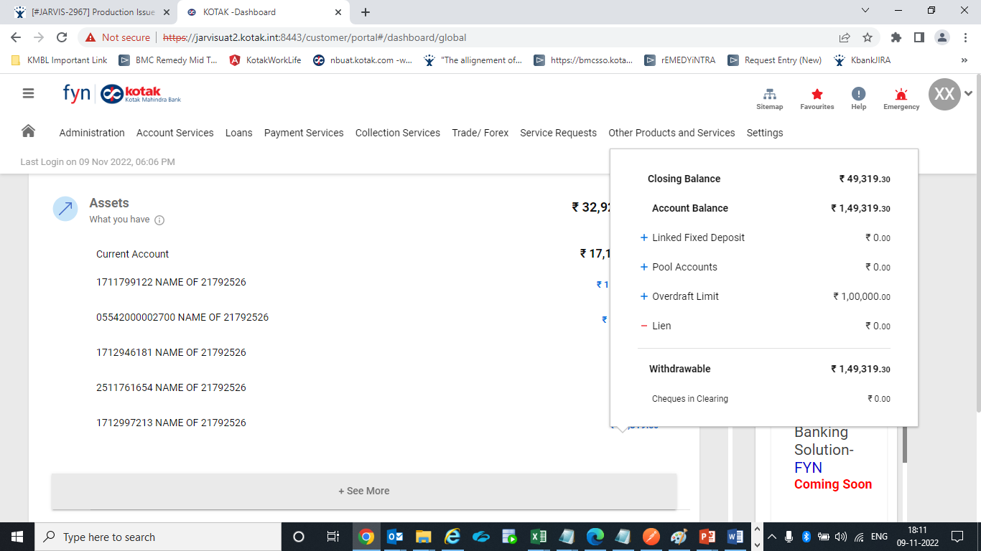

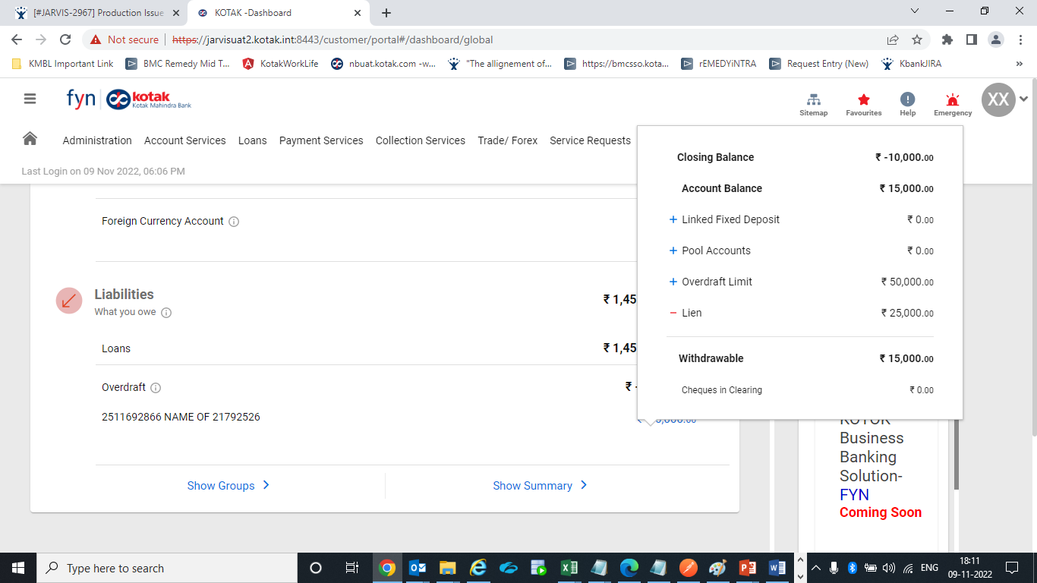

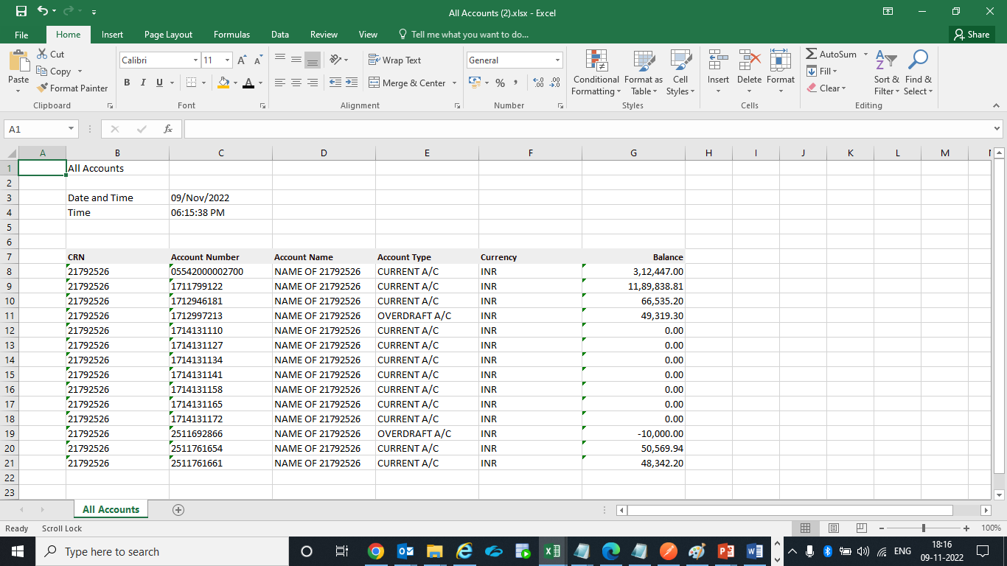

Supporting Document for reference : 

**Req_3 :**

**Screen: Your Repayment Schedule**

Current Scenario: Loan account number is captured in repayment schedule excel/csv report but not in pdf report.

Expected Change: Loan account number is to be captured below CRN details in pdf report also.

Screenshot:

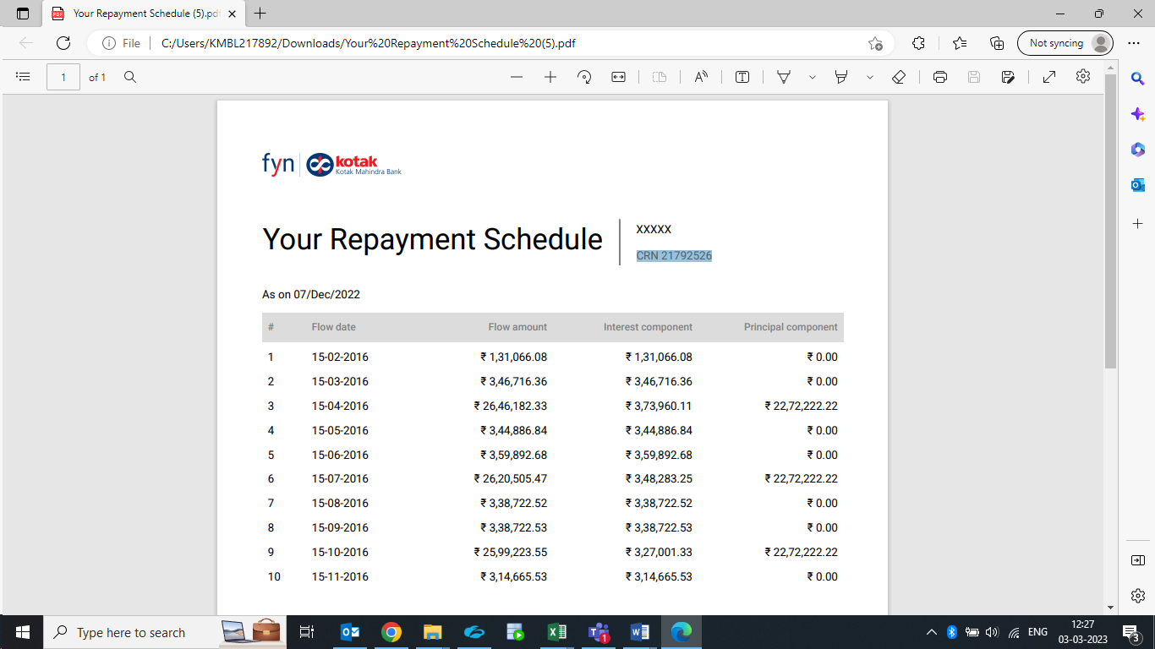

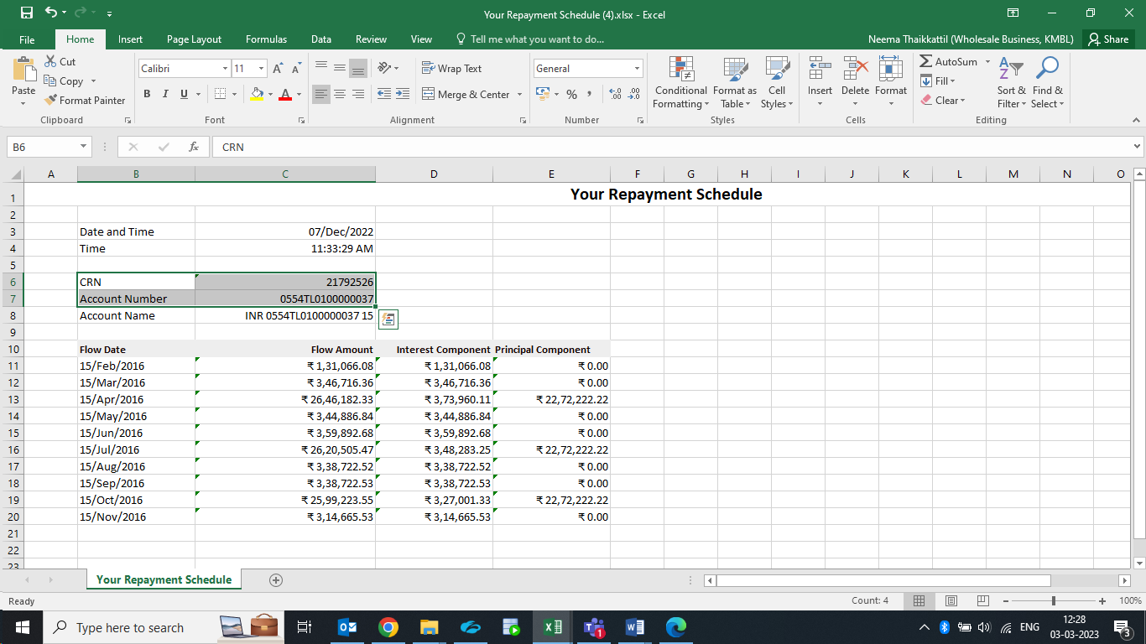

Supporting Document for reference: 

**Req_4 :**

**Screen: Balance Confirmation**

Current Scenario:

Current text:  
“Please feel free to contact our nearest Branch or our 24 hour Customer Contact Centre at 1860-266-2666 for any clarifications.(*Local Call Rates Apply)  
We assure you of our best service at all times and look forward to a long and mutually beneficial relationship.  
Yours faithfully,  
For Kotak Mahindra Bank Ltd.  
Authorised signatory.”

Expected Change:

The current text is to be replaced with below text:  
  
 'This is computer generated advice and does not require any signature'

Screenshot:

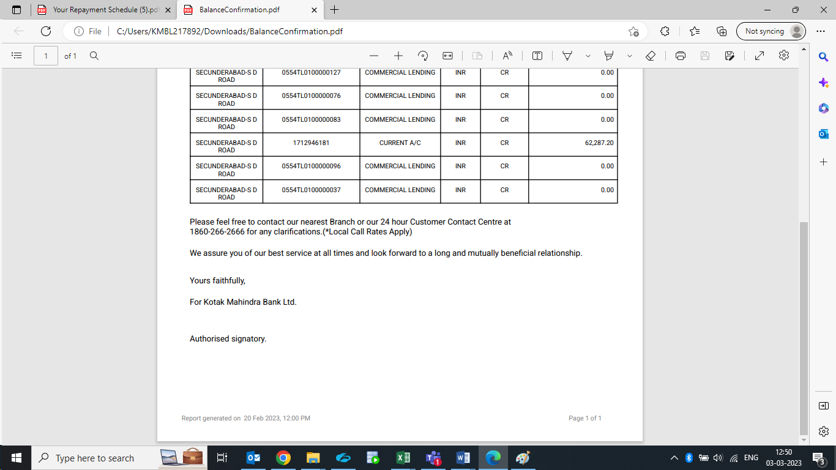

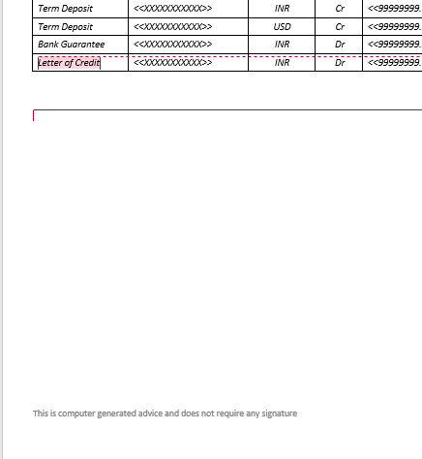

Supporting Document for reference: 

**Req_5:**

**Screen: All account widget**

**The change is to be done on the download format.**

Current Scenario:

1) Balances are in INR  
2) Header is “Balance”

Expected Change:

1) Balances should be in account currency and corresponding currency should reflect on the screen.   
2) Header should be “Balances (A/c Currency)”

Screenshot:

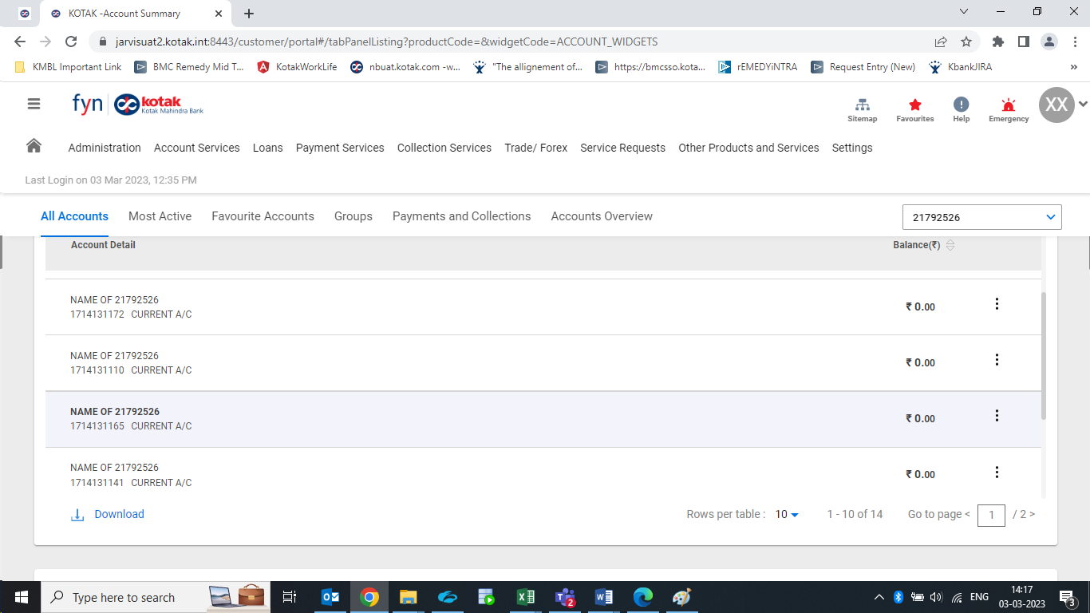

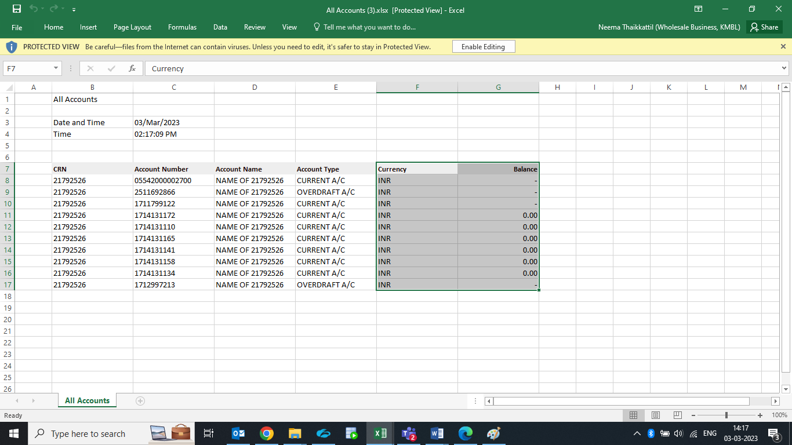

Supporting Document for reference:

**Req_6 :**

**Screen: Favourite Accounts**

**The change is to be done on the download format.**

Current Scenario:

1) Header is “Account number”  
2) Header is “Account name”  
3) Balances are in INR  
4) Header is “Account type”  
5) Header is “Balance”

Expected Change:

1) Header should be “Account Number”  
2) Header should be “Account Name”  
3) Balances should be in account currency and corresponding currency should reflect on the download.   
4) Header should be “Account Type”  
5) Header should be “Balances (A/c Currency)”

Screenshot:

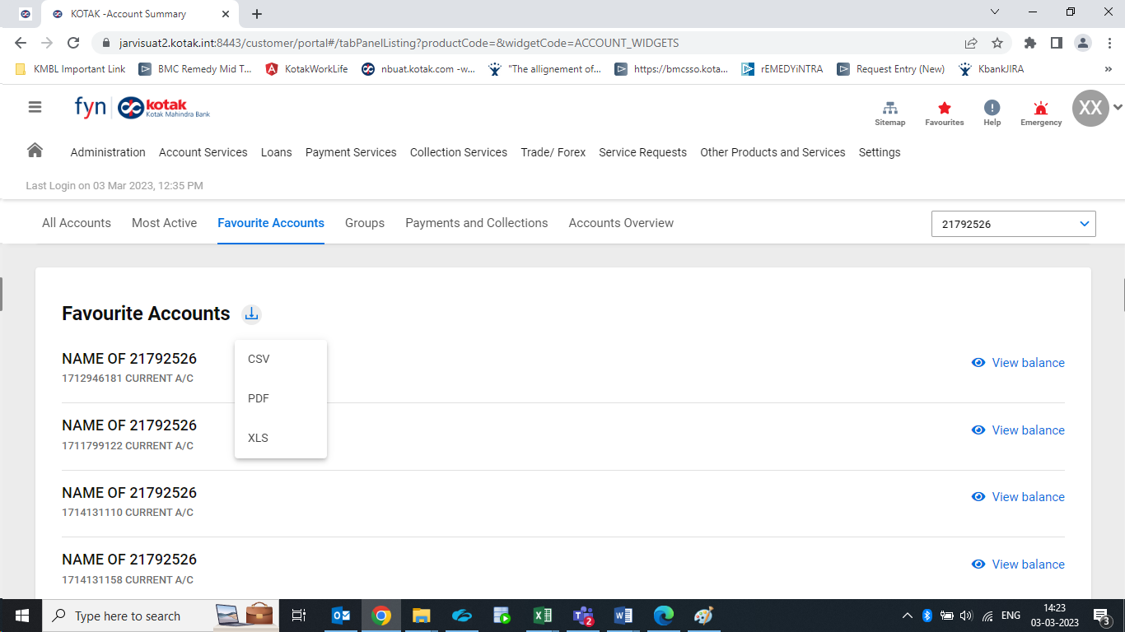

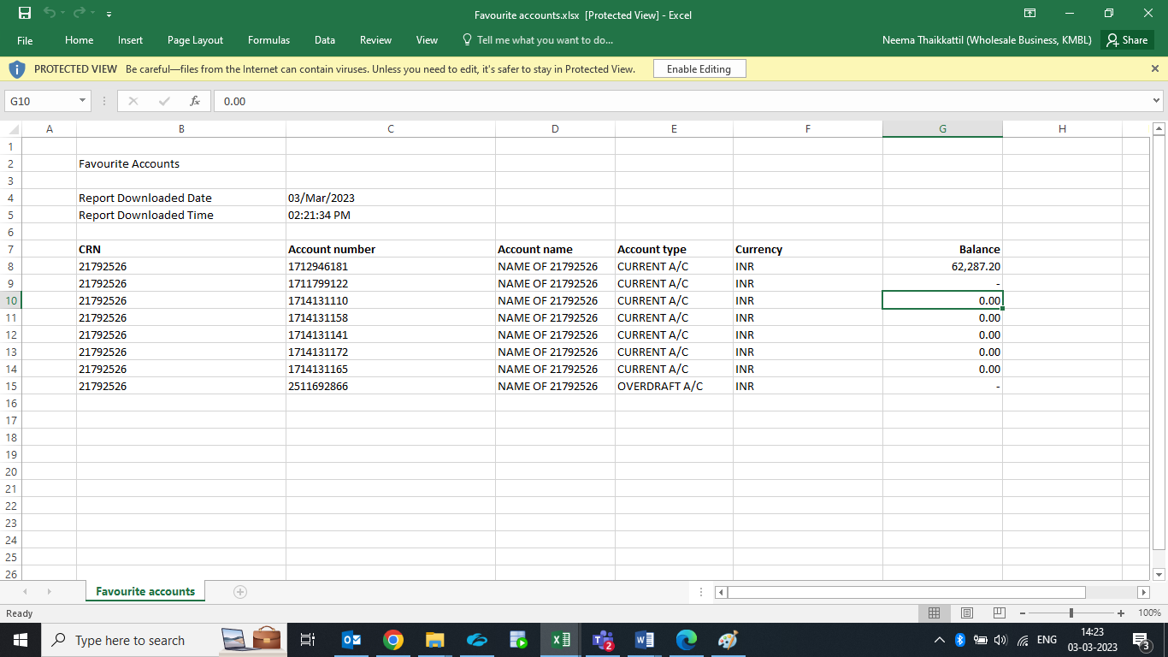

Supporting Document for reference:

**Req_7:**

**Screen: Groups**

**The change is to be done on the download format.**

Current Scenario:

1) Header is “Group name”  
2) Header is “Group total balance”  
3) Header is “Account number”  
4)Header is “Account name”  
5) Header is “Account type”  
6) Header is “Balance”

Expected Change:

1) Header should be “Group Name”  
2) Header should be “Group Total Balance (in INR)”  
3) Header should be “Account Number”  
4) Header should be “Account Name”  
5) Header should be “Account Type”  
6) Header should be “Balances (in INR)”

Screenshot:

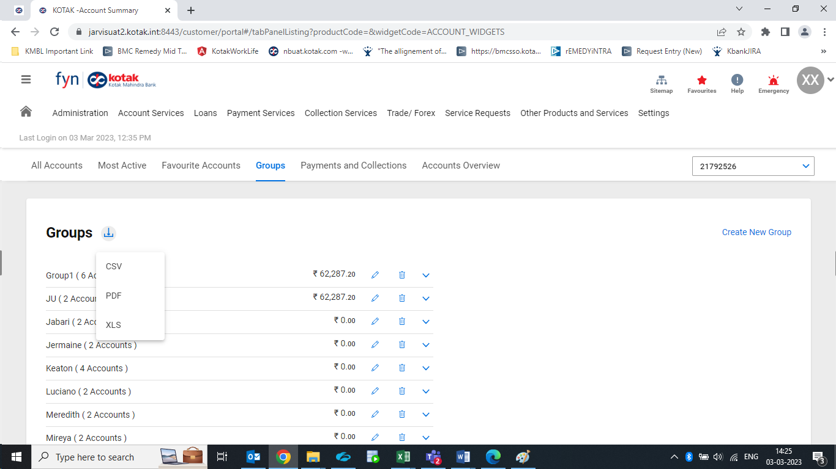

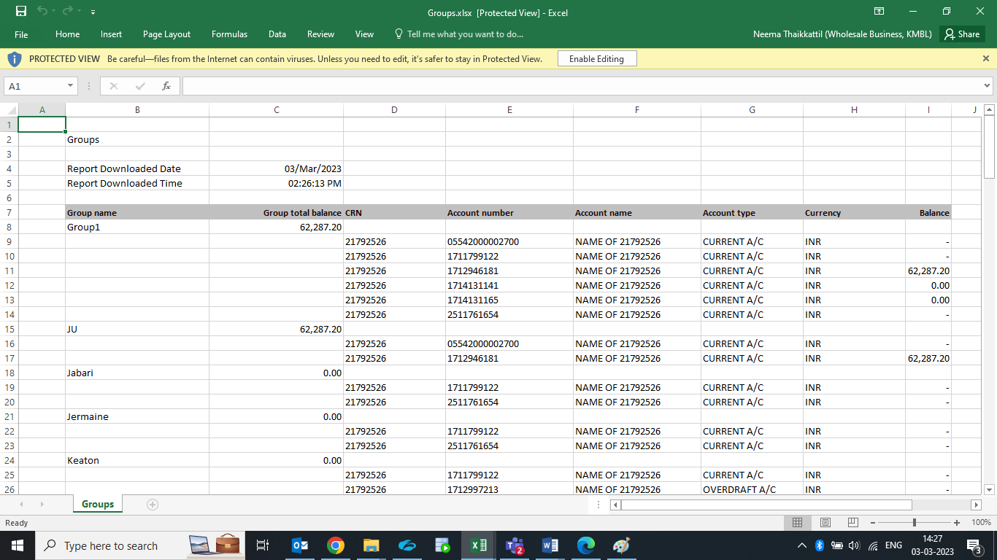

Supporting Document for reference:

**Req_8:**

**Screen: Payment and Collection**

**The change is to be done on the download format.**

Current Scenario:

1) Header is “Group name”  
2) Header is “Account number”  
3) Header is “Account name”  
4) Header is “Account type”  
5) Amount is in INR for Cumulative debit  
6) Amount is in INR for Cumulative credit  
7) Header is “Cumulative debit”  
8) Header is “Cumulative credit”  
9) Total Debit / Total Credit in section above the table

Expected Change:

1) Header should be “Group Name”  
2) Header should be “Account Number”  
3) Header should be “Account Name”  
4) Header should be “Account Type”  
5) *Amount should be in account currency for Cumulative debit  
6) *Amount should be in account currency for Cumulative credit  
7) Header should be “Debit Amount (A/c Currency)”  
8) Header should be “Credit Amount (A/c Currency)”  
9) Total Debit / Total Credit in below section to be updated as “Account Currency”  
10) Report should mentioned the period for which data is downloaded

Screenshot:

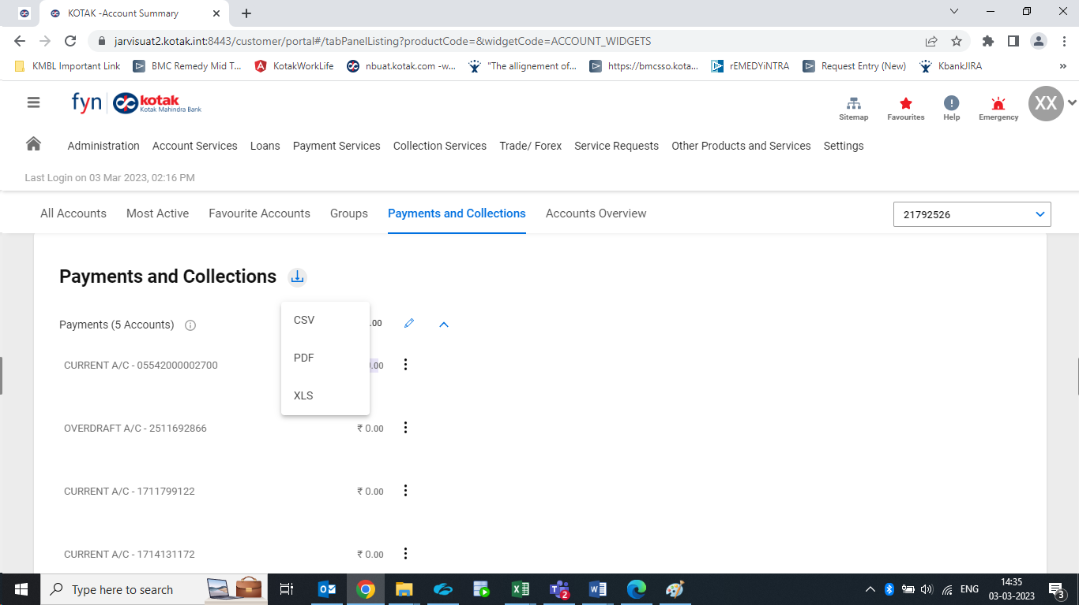

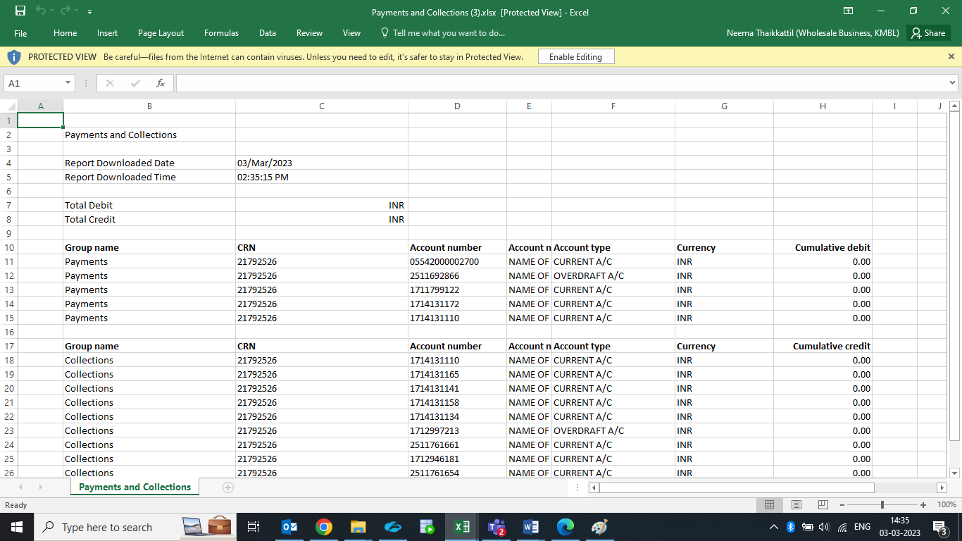

Supporting Document for reference:

**Req_9:**

**Screen: Loan Overview**

**The change is to be done on the download format.**

Current Scenario:

1) Header is “Account Name”  
2) Header is “Maturity”  
3) Header is “Disbursed amount”  
4) Header is “Outstanding amount”  
5) Header is “Overdue amount”

Expected Change:

1) Header should be “Customer Name”  
2) Header should be “Maturity Date”  
3) Header should be “Disbursed Amount”  
4) Header should be “Outstanding Amount”  
5) Header is “Overdue Amount”  
6) Header “Loans Overview” is placed differently compared to the header in other sections. Same needs to be aligned  
7) Mention a line on report that all amounts are in Account Currency  
8) Customer Name is captured in the Account Name field  
9) All the amounts to be displayed in account base currency.

Screenshot:

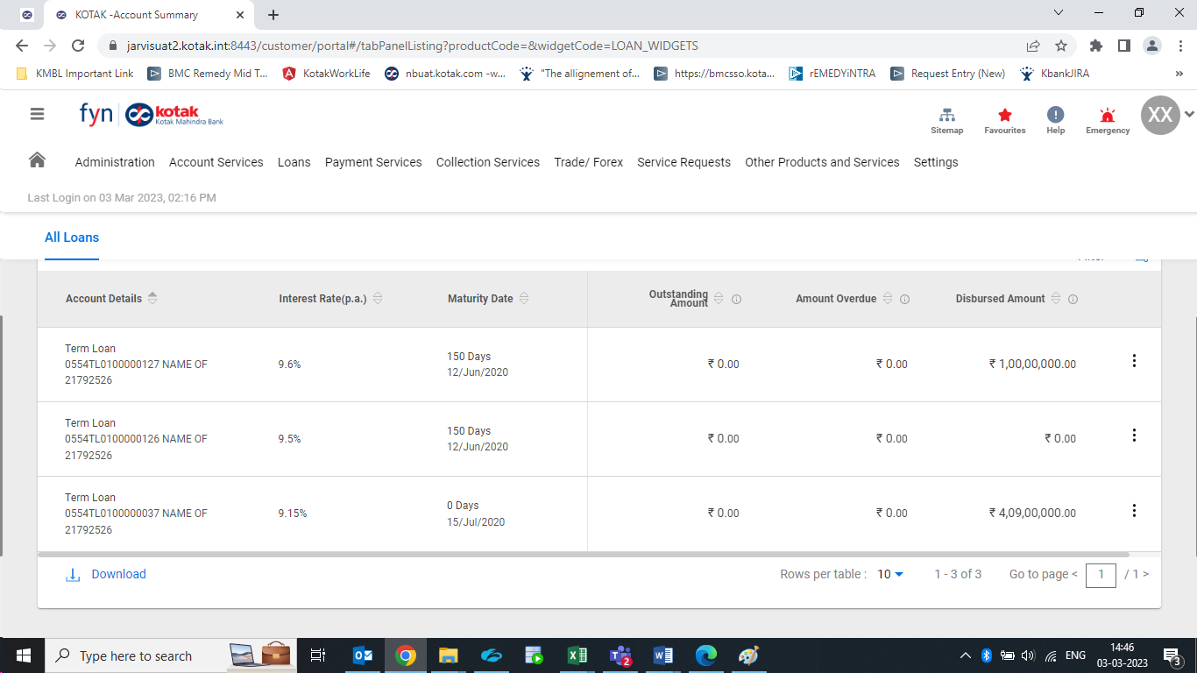

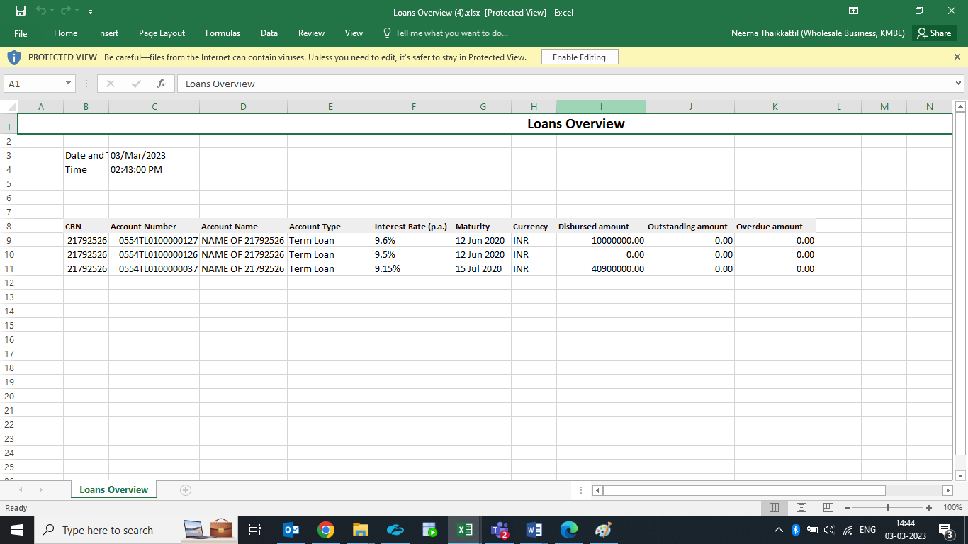

Supporting Document for reference:

**Req_10:**

**Screen: Your Repayment Schedule**

**The change is to be done on the download format.**

Current Scenario:

1) Header “Your Repayment Schedule” is placed differently compared to the header in other sections. Not aligned.  
2) ₹ symbol should present  
3) Account Name is displayed  
4) pdf report has number field

Expected Change:

1) Header “Your Repayment Schedule” is placed differently compared to the header in other sections. Same needs to be aligned.  
2) All amounts should be in A/c currency  
3) ₹ symbol should not be there  
4) Account Name to be replaced with “Customer Name” & name of customer must be captured in below section  
5) In pdf report # field need not be captured

Screenshot:

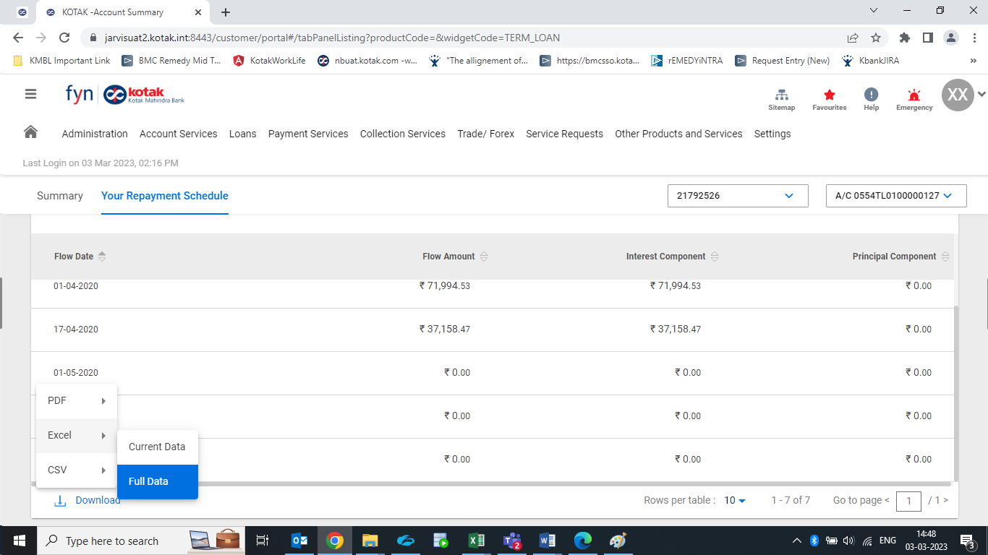

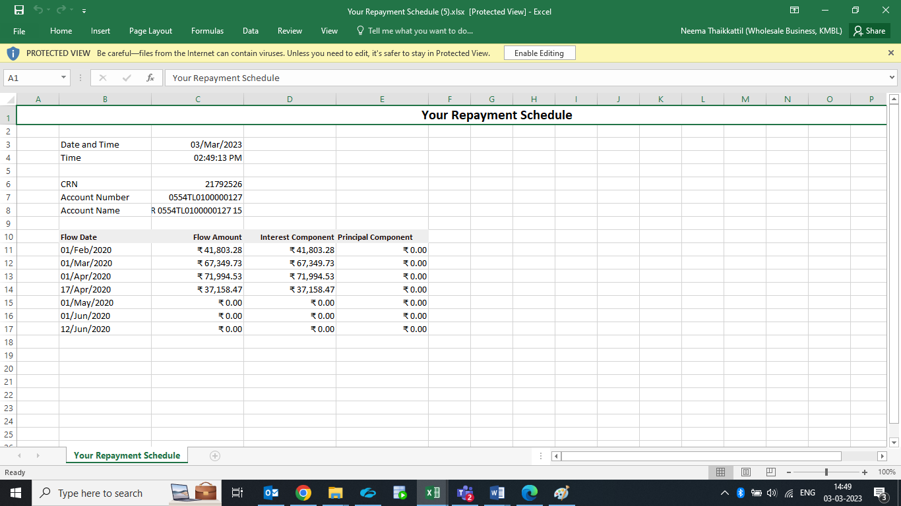

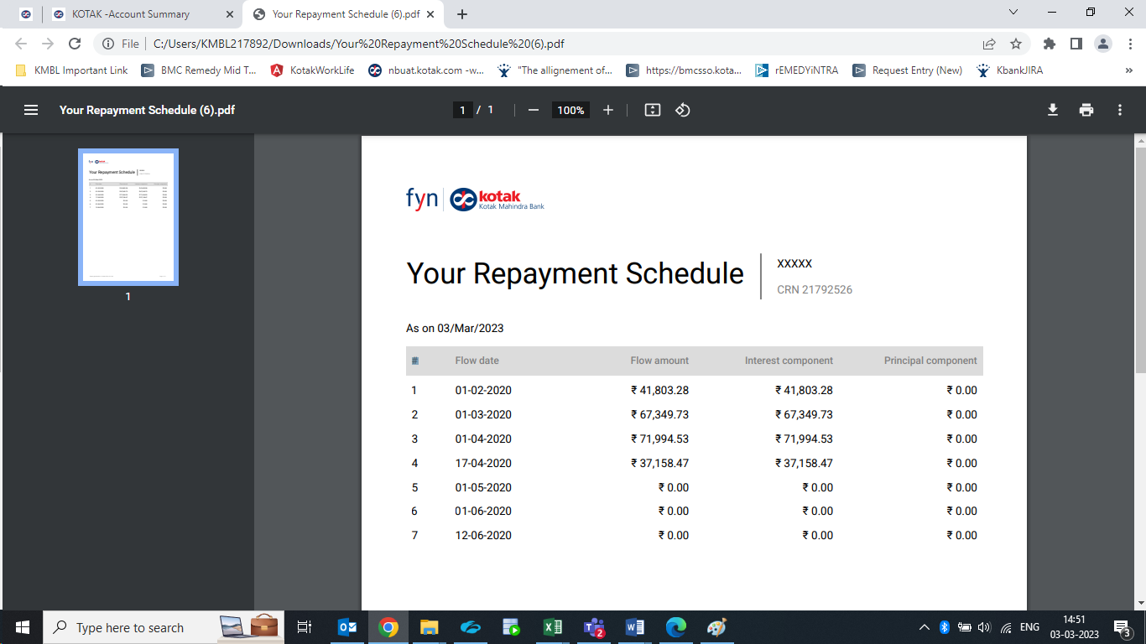

Supporting Document for reference: 

**Req_11:**

**Screen: Your loans**

**The change is to be done on the download format.**

Current Scenario:

1) Header is “Loan account #”  
2) Header is “Name of A/C”  
3) Header is “Interest rate (p.a.)”  
4) Header is “Start date”  
5) Header is “Benchmark rate”  
6) Header is “Amount overdue”  
7) Header is “last reset date”  
8) Header is “next reset date”  
9) Contents should be vertical in pdf and horizontal in excel

Expected Change:

1) Header should be “Loan Account Number”  
2) Header should be “ Name of Customer”  
3) Header should be “Interest Rate (p.a.)”  
4) Header should be “Start Date”  
5) Header should be “Benchmark Rate”  
6) Header should be “Amount Overdue”  
7) Header should be “Last Reset Date”  
8) Header should be “Next Reset Date”  
9) Contents should be vertical & not horizontal in all formats  
10) Currency of Loan must be captured1 `  
11) All amounts should be in account currency. Mention a line on report that all amounts are in Account Currency  
12) Customer Name is captured in the Name of A/C  
13) Sequence of data should be as below:   
CRN  
Loan account #  
Name of A/C  
Product  
Start date  
Loan Tenure  
Maturity Date  
Residual Tenure  
Interest rate (p.a.)  
Benchmark  
Benchmark rate  
Spread  
Outstanding Amount  
Disbursement Amount  
Amount overdue  
Status  
last reset date  
next reset date

Screenshot:

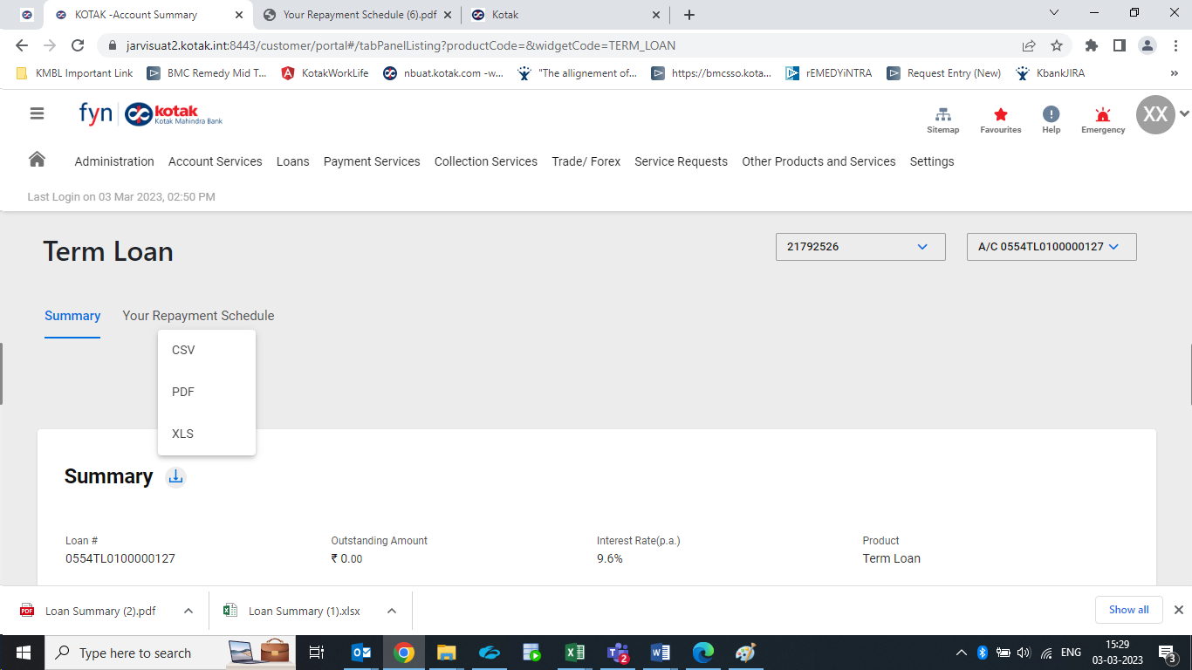

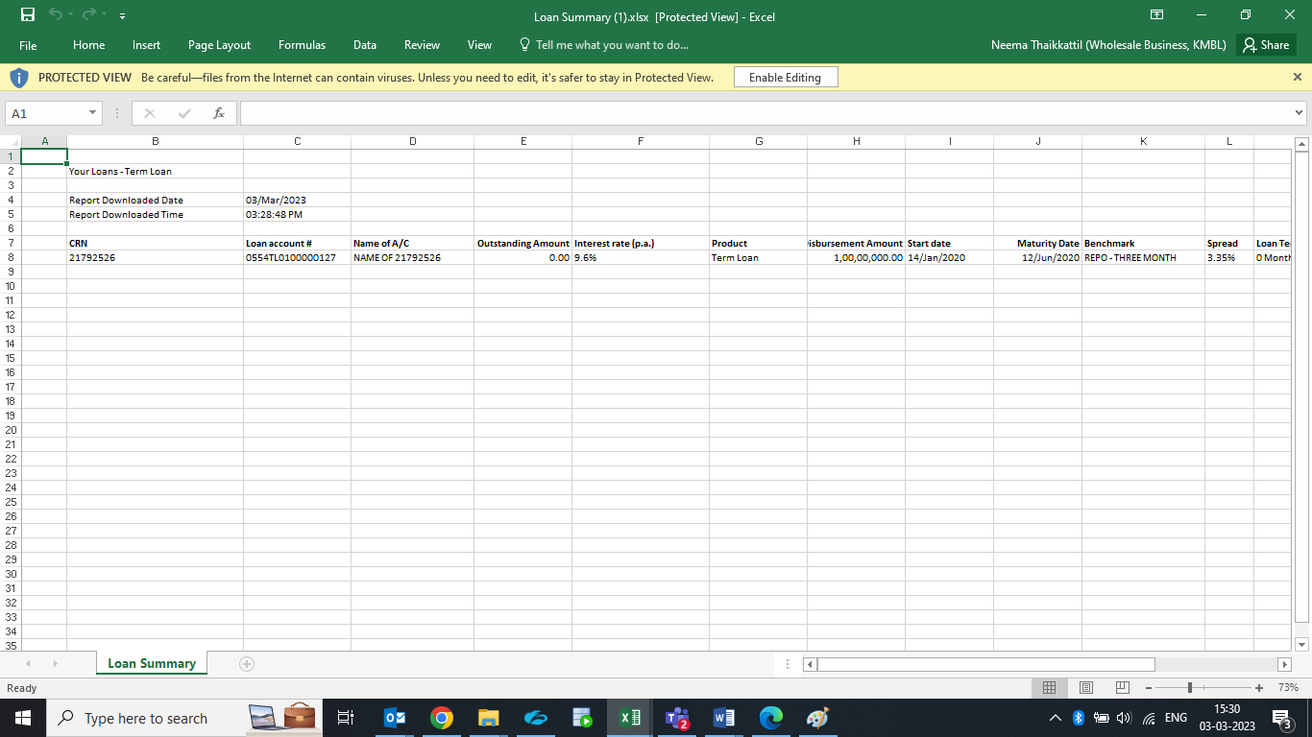

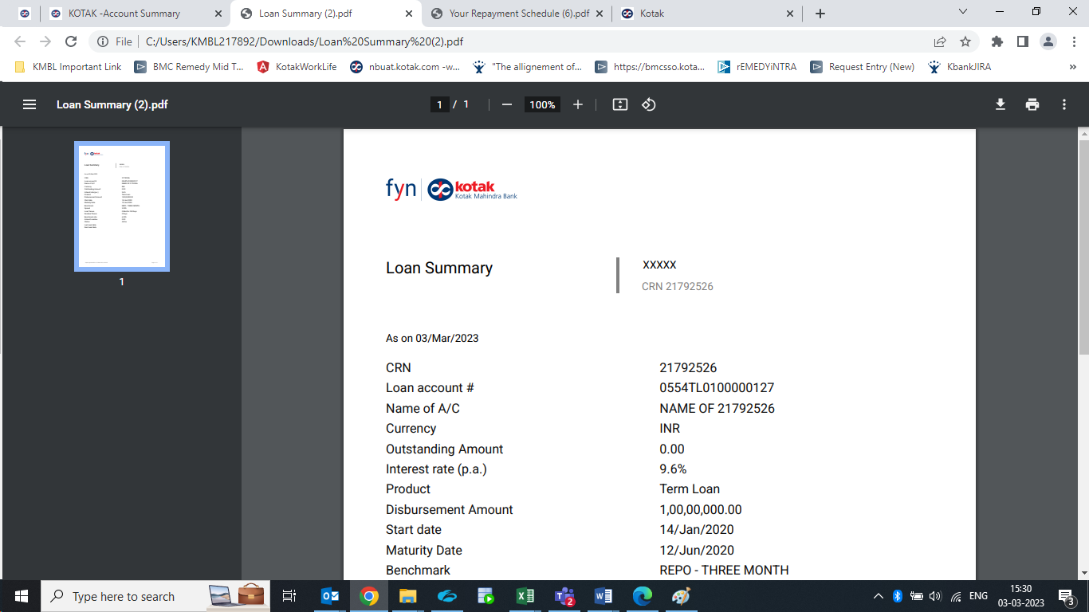

Supporting Document for reference:

**Req_12:**

**Screen: Your Summary widget**

**The change is to be done on the download format.**

Current Scenario:

1. Header is “Account number”
2. Header is “Account name”
3. Header is “Account type”
4. Header is “Balance (Base Currency)”

Expected Change:

1) Header should be “Account Number”  
2) Header should be “Account Name”  
3) Header should be “Account Type”  
4) Header should be “Balance (A/c Currency)”  
5) Category shouldn’t be in column A. All details should be captured from Column B only for excel and csv format  
6) All Assets is to be shown first & then liability  
7) For Loans, Balance (A/c Currency) should be replaced by Outstanding (A/c Currency)  
8) All amounts should be shown in currency of account  
9) Sorting to be done basis Account Type  
10) Account name to be replaced by “Customer Name” for loans

Screenshot:

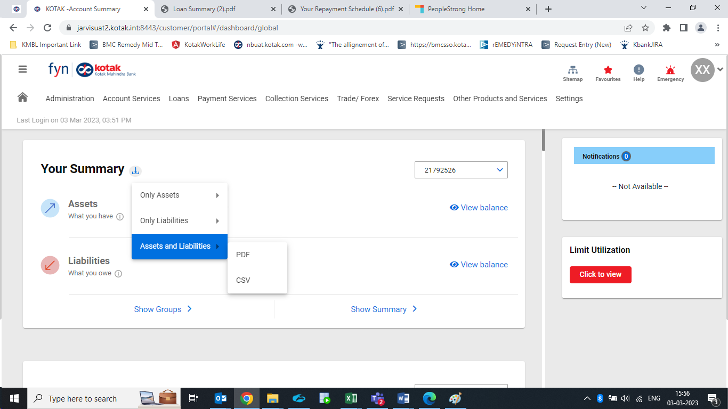

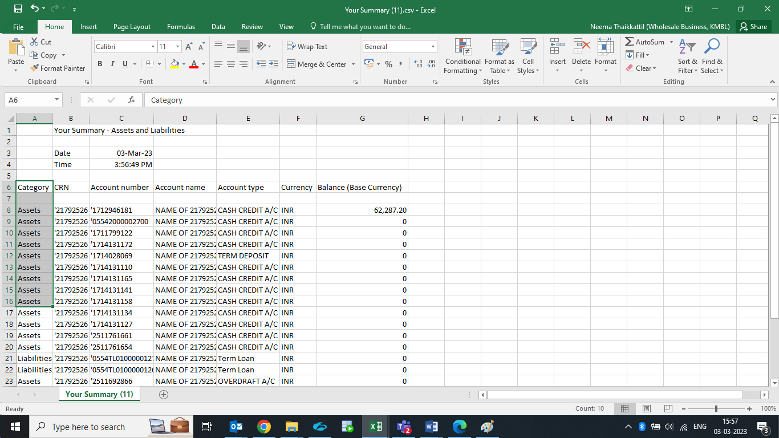

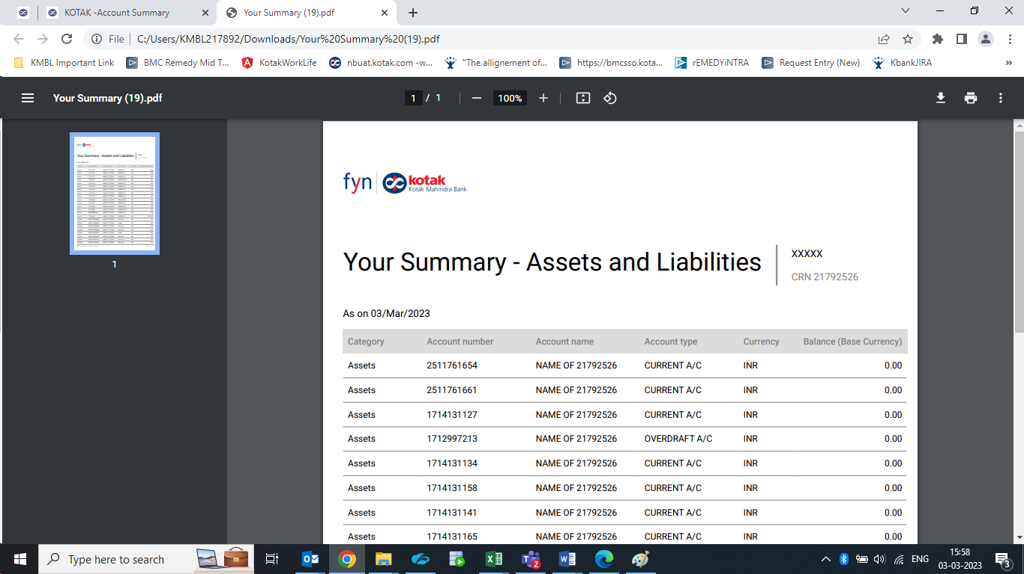

Supporting Document for reference:

**Req_13:**

**Screen: Verbiage change in (i) icon - Your Summary**

**The change is to be done on the download format.**

Current Scenario:

Change/Feedback 1: Changes in content of (i) icon in Assets  
Current:  
Available balances maintained across all accounts (INR / FCY / Deposit) excluding unclear funds & any amount on hold (lien).  
• Change/Feedback 2: Changes in content of (i) icon in Overdraft under Liability  
Current:  
Non utilized overdraft limit

Expected Change:

Change/Feedback 1: Changes in content of (i) icon in Assets  
Proposed:  
Available Bbalances maintained across all accounts (INR / FCY / Deposit) excluding unclear funds & any amount on hold (lien).  
• Change/Feedback 2: Changes in content of (i) icon in Overdraft under Liability  
Proposed:  
-- Icon in overdraft limits needs to be removed   
Screenshot:

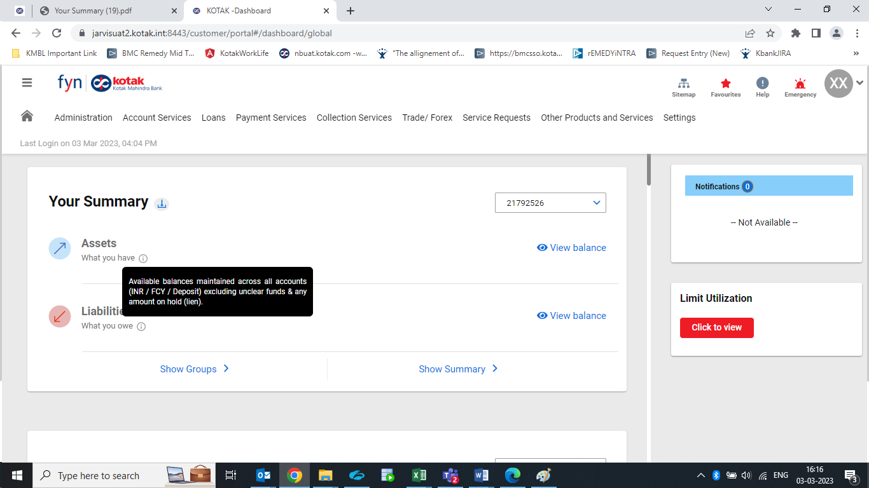

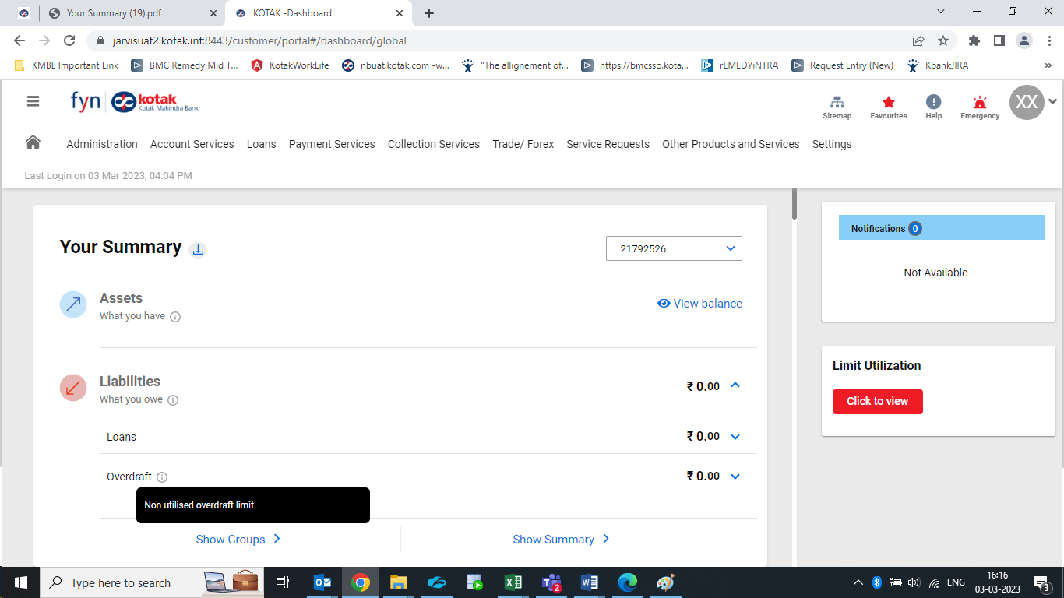

Supporting Document for reference:

**Req_14:**

**Screen: Your Summary**

Current Scenario:

1) Feedback on name of account in Assets section - account no followed by name of entity  
2) All the accounts are reflecting on selection of see more

Expected Change:

1) Account no followed by name of entity. It should be name of account  
2) When we select see more, we should see only 10 account but in UAT we are able to see multiple account. We should be able to see only 10 on this page

Screenshot:

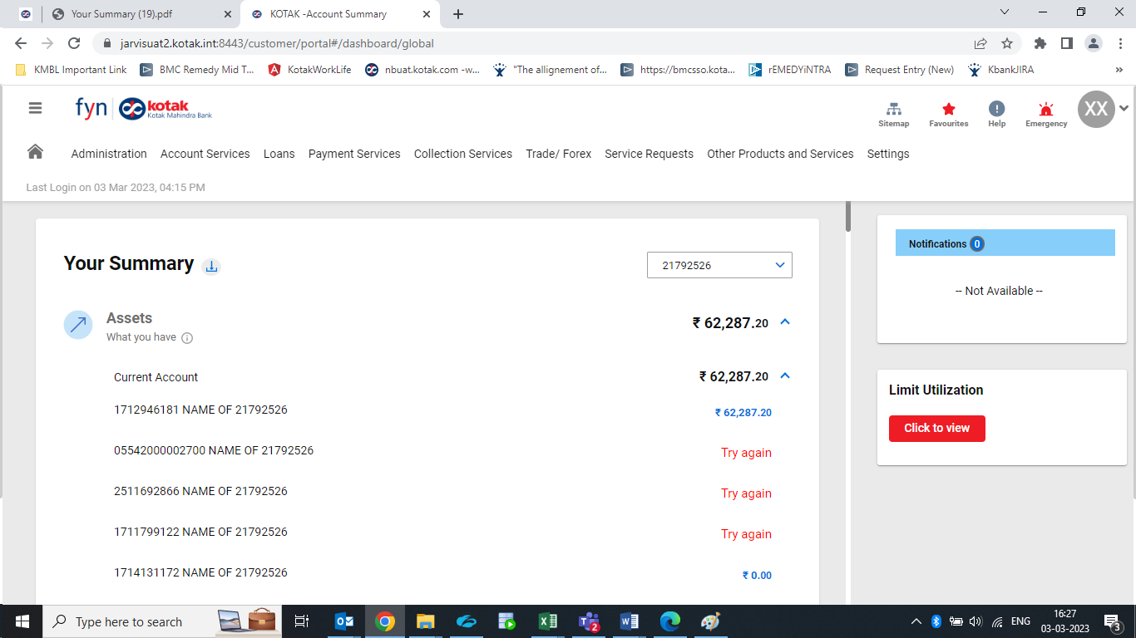

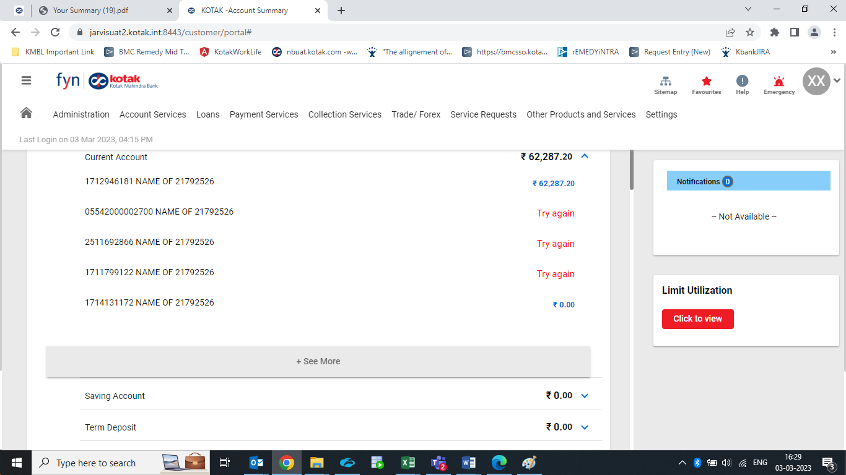

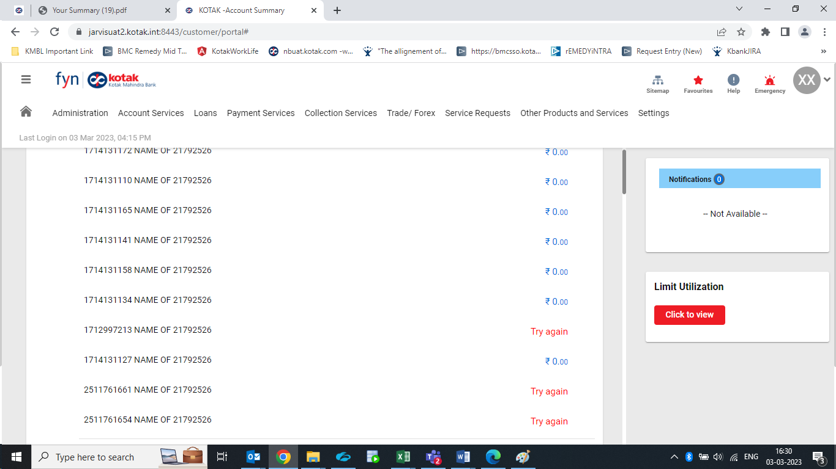

Supporting Document for reference:

**Req_15:**

**Screen: Term Deposit Summary Screen**

Current Scenario:

1) ü Interest Pay plan is seen as “3 months”  
2) Product is captured as “Term”

Expected Change:

1) ü Interest Pay plan is seen as “3 months”, it should be Daily, Quarterly depending on the interest plan opted for, the change has to be done across all reports and widgets.  
2) Product should be Term Deposit - across all widgets and reports currently captured as “Term”  
3) The changes should reflect on screen and the downloads.

Screenshot:

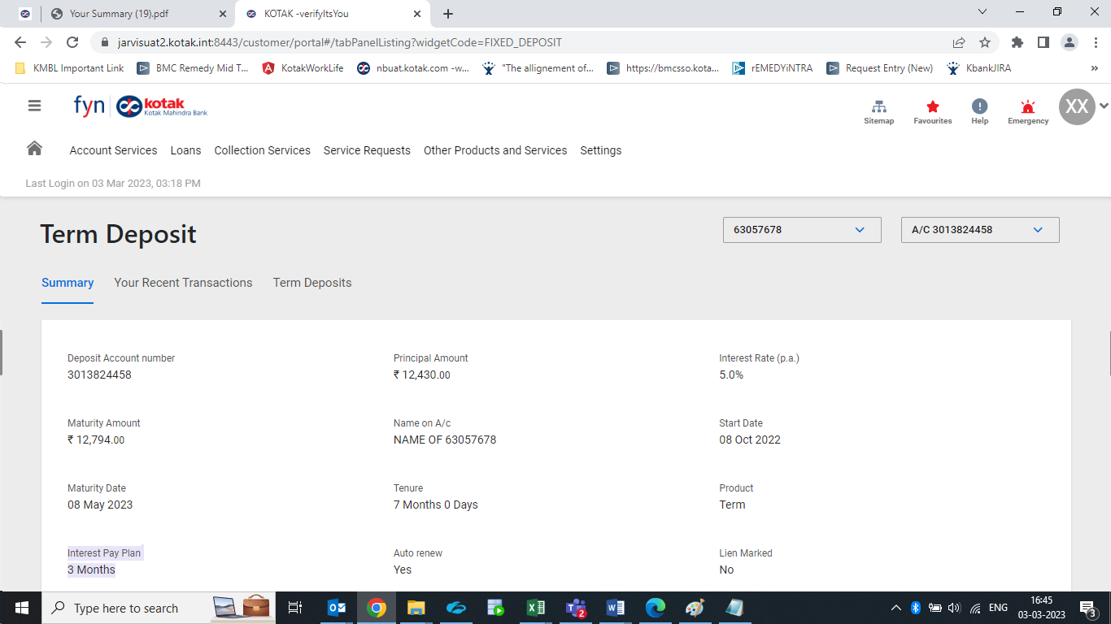

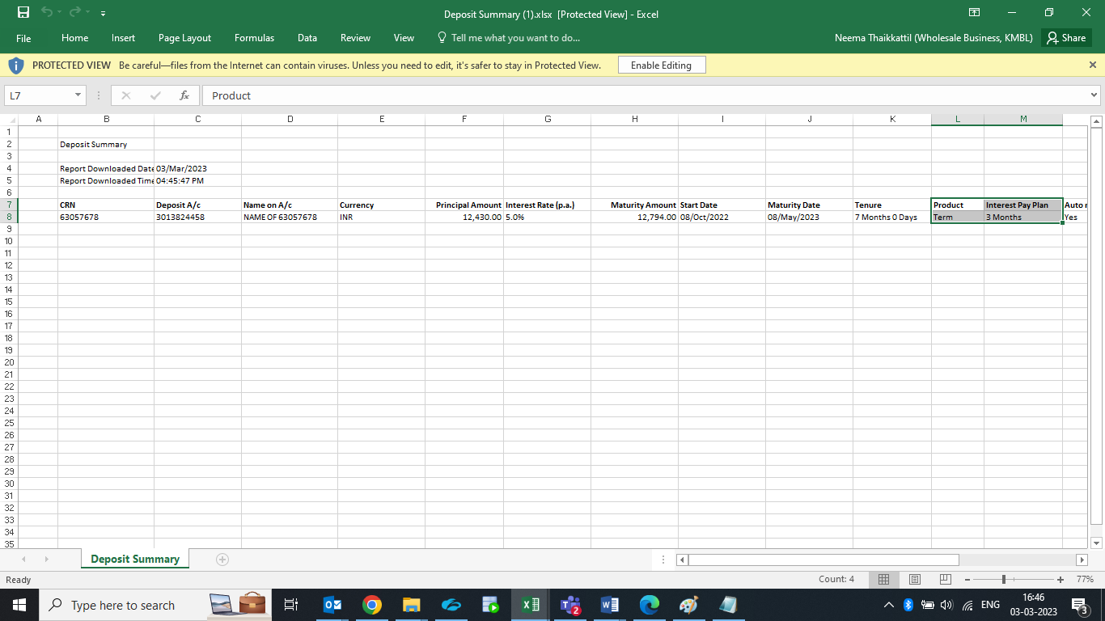

Supporting Document for reference: 

**Req_16:**

**Screen: Heading - Term Deposit Overview**

**The change is to be done on the download format.**

Current Scenario: Only seen in Excel format, missing in CSV format

Expected Change: The heading needs to be added in CSV format

Screenshot:

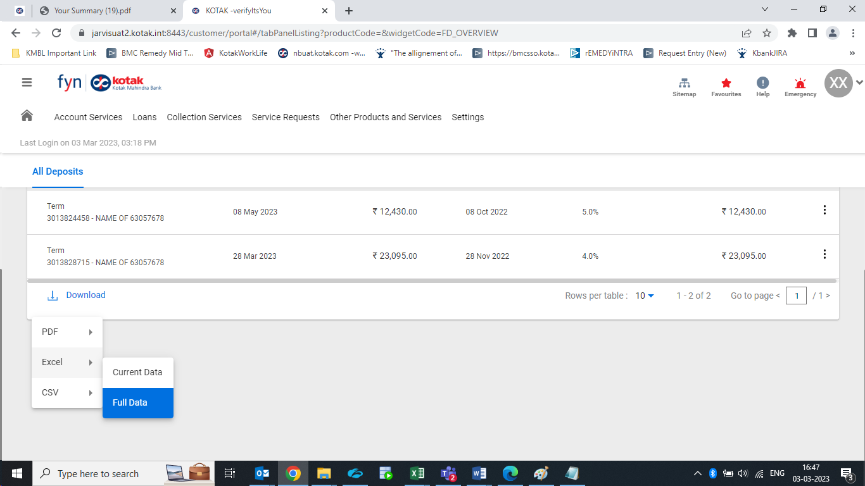

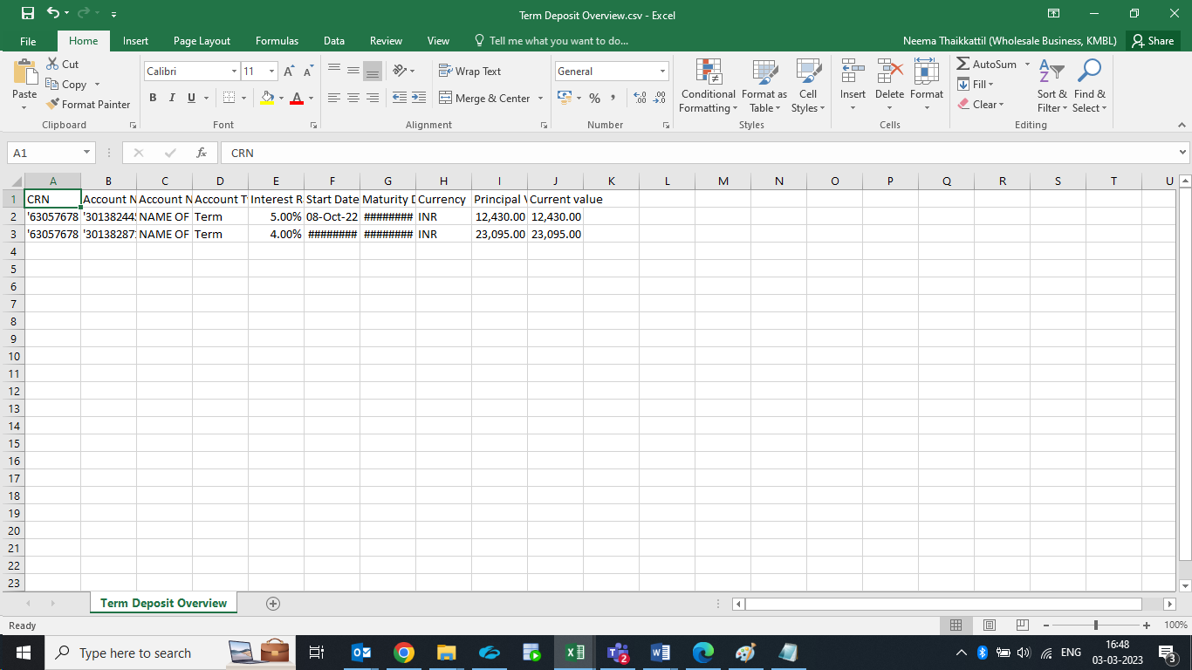

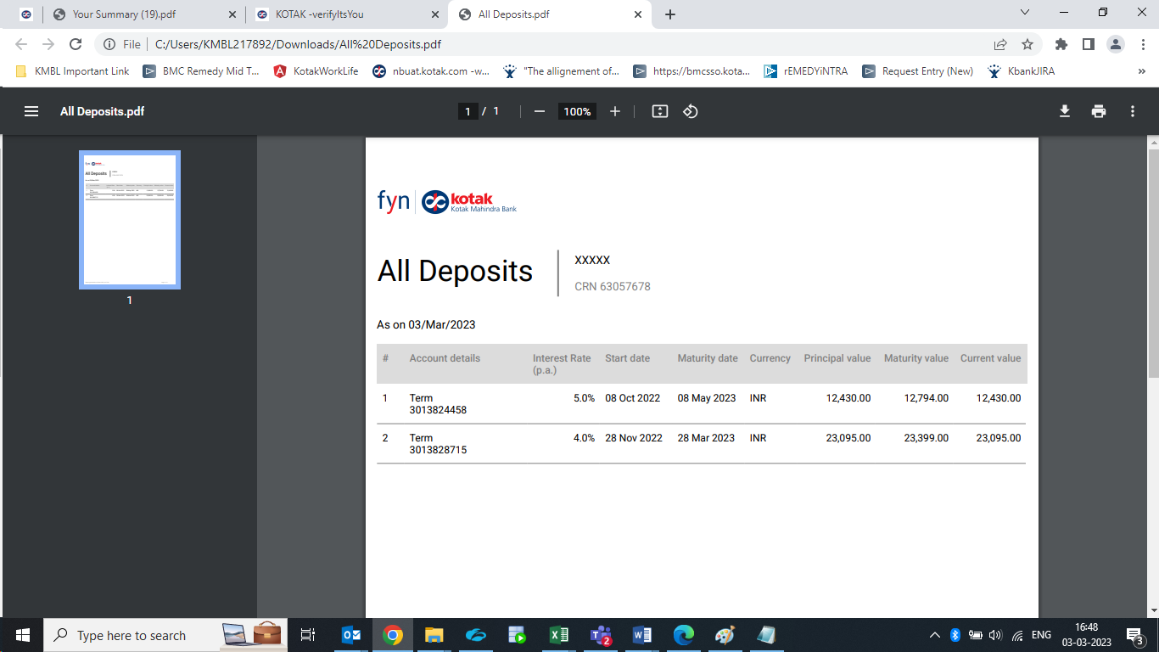

Supporting Document for reference:

**Req_17:**

**Screen:** Pl. Note – TD Stmnt PDF

**The change is to be done on the download format.**

Current Scenario:

Verbiage is incorrect in point 1

Expected Change:

Needs correction

Screenshot:

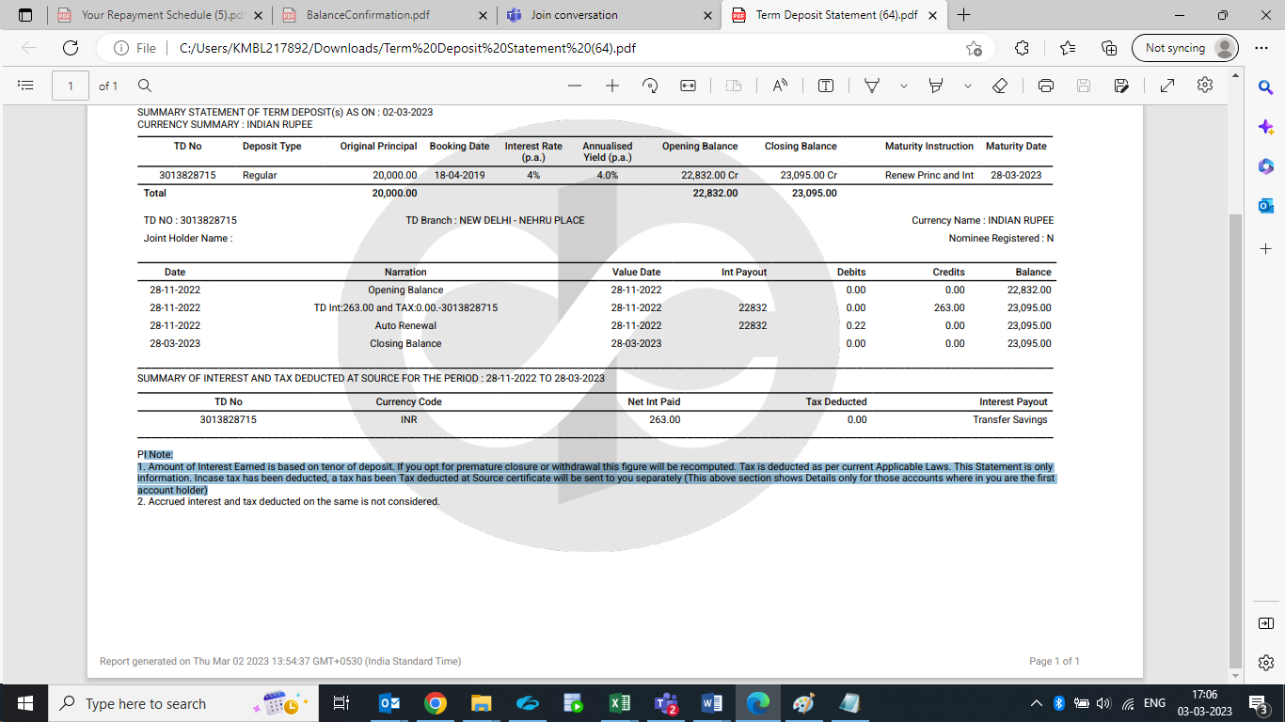

Supporting Document for reference:

**Req_18:**

**Screen: TD Stmnt PDF – Date and Time**

**The change is to be done on the download format.**

Current Scenario: Shows time, day , date and GMT – India Standard Time, Other report have only date and time

Expected Change: Has to be standard across all reports

1. Why is the opening balance seen in Interest Payout ? – This needs to be rectified.
2. What is the 0.22 amount seen in debits? – This needs to be rectified.
3. The note at the end of the state needs an addition, highlighted

PI Note:

1. Amount of Interest Earned is based on tenor of deposit. If you opt for premature closure or withdrawal this figure will be recomputed. Tax is deducted as per current Applicable Laws. This Statement is only **for** information. Incase tax has been deducted, a tax has been Tax deducted at Source certificate will be sent to you separately (This above section shows Details only for those accounts where in you are the first account holder)

2. Accrued interest and tax deducted on the same is not considered.

1. Report generated on Thu Mar 02 2023 13:54:37 GMT+0530 (India Standard Time) – it has to be std and this feedback was also given earlier
2. Kotak Logo watermark is large, needs to be same size across all reports, this feedback was also given earlier.

Screenshot:



Supporting Document for reference:

**Req_19:**

**Screen: TD Interest Cert PDF – Table grid**

**The change is to be done on the download format.**

Current Scenario: format is Bold

Expected Change: Should not be Bold

1. Report generated on 02 Mar 2023, 2:00 PM – this is different from TD statement – it has to be std and this feedback was also given earlier.
2. Kotak Logo watermark is small, needs to be same size across all reports, had already given this feedback last time also
3. Alignment of headers in the table also does seem to be right.

Screenshot:



Supporting Document for reference:

**Req_20:**

**Screen: Watermark**

**The change is to be done on the download format.**

Current Scenario: Are of different sizes and alignments are all also different

Expected Change: The watermark has to be centrally aligned as per the report and the size has to be same across all reports.

Screenshot:





Supporting Document for reference:

**Req_21:**

**Screen: Deposit Type – TD Advice**

**The change is to be done on the download format and screen.**

Current Scenario: Deposit type : Reinvestment

Expected Change: Deposit type : Should be the description of the scheme code

1. Date spacing needs to be corrected
2. Gap between each address line is wide needs to be reduced.
3. Alignment of RHS fields is not proper.
4. Deposit Type : Reinvestment – please have this rechecked
5. Kotak Logo watermark is small, needs to be same size across all reports, had already given this feedback last time also
6. Conditions - changes were requested in our earlier calls, but nothing seems to be have done by Finastra.

This is a Fixed Deposit Advice and no lien can be marked on this document

Non submission of PAN by depositor(s) will attract higher rate of TDS as applicable

Incase from 15G/H is being submitted to the bank, PAN mentioned on the form should be match with Bank records.

Incase of premature withdrawal, Interest will be paid at:

a) The rate prevailing on the date of Deposit for the tenure the deposit or the withdrawal amount remained with Bank or at the contracted rate,

whichever is lower post deducting applicable penal charge for premature withdrawal as per the Terms & Conditions of the Bank.

b) For FCNR(B)/NRE Deposit, in addition to the the above point,no interest will be paid on principal amount withdrawal from FCNR (B)/NRI term term deposit before completion of the year

For Fixed Deposit with a tenure below 181 days, interest will be calculated and paid on maturity as per simple interest method.

Repayment/renewal of deposit shall be effected as per the maturity instruction recorded with bank at the time of booking the fixed Deposit

In absence of maturity instructions, the Fixed Deposit will be renewed automatically,without any liability to the bank,for the same tenure and at the

interest rate prevailing on the date of renewal.

Where maturity instrutions are for repayment and not for renewal, interest will be ceased to the payable at the end period of the deposit.

Facilty of renewal with restrospective effect is not available with respect to deposit has been overdue beyond 14 days

Any change of maturity instruction shall be intimated to the bank minimum 7 days prior to maturuity ofdeposit.

All Communications to the bank should consist of the fixed deposit Number/Customer Relationship Number.

Any change of address should be communicated to the bank along with acceptable address proof Document for new address.

The calculation of interest is basis 365 days in a year for deposit**s** booked in a non-leap year and 365 days in year for fixed deposit is booked in leap year

The Fixed Deposit is governed by the term and conditions of the bank. Please visit your nearest branch for details.

The above terms and conditions are subjected to change without notice.

Fixed Deposit Renewal Details:

Tenor*__________year(s)__________month(s)_____________day(s)* If fixedDeposit tenure is less than Six Months please mention tenure in days only

Maturity Date: Monthly | Quaterly Payout Cumulative

Interest frequency (Tick any one) Auto Renew principal Auto Renew principal & interest

Maturity instruction (Tick any one) Repay Principal Auto Renew principal & pay interest

Reprincipal & interest

Sweep In

Nomination

letter Furnished Not Furnished

This is a Computer generated Advice and therefore Does not Require a signature.

you may call our 24-hour Customer Contact Center at our Tollfree Numbers-1860 266 2666 or write us at Customer Contact Center kokak Mahindra Bank,PO BOx No.06344,Mumbai 40013

1. Report generated on Thu Mar 02 2023 13:54:51 GMT+0530 (India - it has to be std and this feedback was also given earlier

Screenshot:

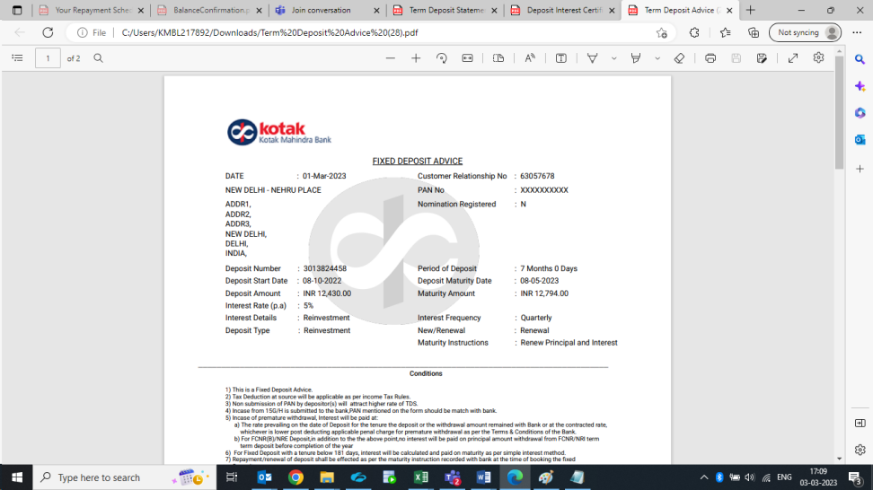

Supporting Document for reference:

# Processing Flow Diagram

N.A>

# Change Type:

UI/Functional as mentioned in above table under Head “Type of Change”

# Impact Assessment

## 5.1 Accounting

## 5.2 Upstream Data/Systems

## 5.3 Downstream Data/Systems

Finacle API/DWH

## 5.4 User Entitlements

## 5.5 Reports

## 5.6 Correspondences/Advises

## 5.7 Operational Impact (User Processing)

# Dependencies

Dependencies related to Auto Onboarding should be consider which doing changes.

# List of Rules/ Validations

# Test Data/Acceptance Criteria